Hurricane Irma
Date: August 30th 2017- September 14th 2017
Hazard: hurricane
Hazard details: category 4/5
Towns effected: Cuba, Florida, Bahamas and Caribbean
Deaths: 24
Details:
Hurricane Irma was an extremely powerful cape Verde type of hurricane the most intense observed in the Atlantic since Dean in 2007, Irma caused wide spread damage throughout its long life time (15 days) particularly in parts of the northern Caribbean and Florida.
Irma developed on August 30th 2017 near Cape Verde Island from a tropical wave that had moved off the West African coast 3 days prior shortly after formation becoming category 2 on the saffirsimpson scale, within 24 hours it was at category 3; on September 4th it became category 5.
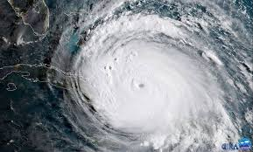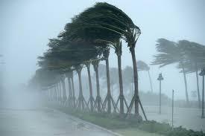
Hurricane Maria
Date: September 16th 2017- October 3rd 2017
Hazard: hurricane
Hazard details: category 5
Towns effected: Puerto Rico, Dominican Republic, Bahamas, United States, Spain, France, England and Ireland
Deaths: 583
Details:
Hurricane Maria is regarded as the worst natural disaster on record in Dominica and caused catastrophic damage and a major crisis in Puerto Rico.
The tenth most intense Atlantic hurricane on record, Maria was the thirteenth named storm.
Originating from a tropical wave, Maria became a tropical storm, produced extreme winds across Dominica.
Total losses from the hurricane are estimated between $15.9 and $95 billion mostly in Puerto Rico.
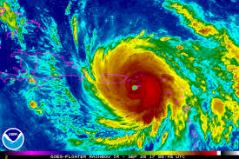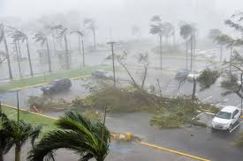
Earthquake in Mexico
Date: September 19th 2017- September 23rd 2017
Hazard: earthquake
Hazard details: magnitude 7.1
Towns effected: Mexico (Puebla, Morelos)
Deaths: 370
Details:
2017 central Mexico earthquake struck at 13:14pm with estimate magnitude of 7.1 and strong shaking for about 20 seconds. Its epicentre was about 55km south of city Puebla.
The earthquake caused damage to Puebla and Morelos including collapsing of 40 buildings more than 6,000 were injured and 370 deaths.
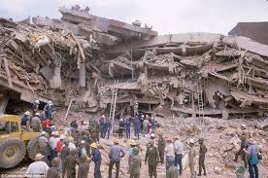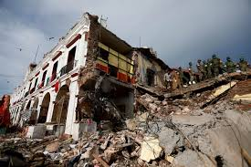

Hurricane Nate
Date: October 4th 2017- October 11th 2017
Hazard: hurricane
Hazard details: 150km/h
Towns effected: America, Cuba and Canada
Deaths: 45
Details:
Hurricane Nate was an unusually fast moving tropical cyclone that caused wide spread destruction in Central America. The fourteenth named storm and ninth hurricane of 2017 Atlantic hurricane season.
Nate originated from a broad area of low pressure over the Caribbean.
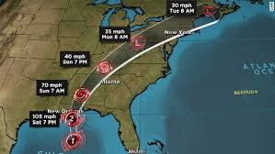

Wildfires in California
Date: October 1st 2017- October 11th 2017
Hazard: wild fires
Hazard details: 4,401.52 km of California burned
Towns affected: California (Napa, Lake Sonoma and Mendocino)
Deaths: 43
Details:
During the month of October a series of fires broke throughout Napa, Lake Sonoma, Mendocino and butte countries during severe fire weather.
Conditions effectively leading a major red flag warning. In extreme conditions the fires grew spanning from 1,000 to 20,000 acres within a day.
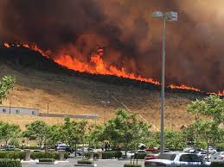

Floods in Australia
Date: October 2nd 2017 – October 3rd 2017
Hazard: flooding
Hazard details: flash flood, urban flood 319mm of rain in 1hr
Towns effected: Bundaberg and Queensland
Deaths: 0
Details:
Torrential rain and strong wind have caused flash flooding and left over 4,000 homes without power.
Recorded 319mm of rain in 24hrs, between 2nd and 3rd of October over 100mm fell between 13:00-15:00pm on the 2nd of October.
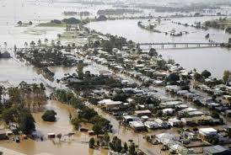

Hurricane Ophelia
Date: October 9th 2017 – October 20th 2017
Hazard: hurricane
Hazard details: 185km/h
Towns effected: Portugal, Spain, France, Ireland, England, Norway and Sweden
Details:
Hurricane Ophelia was the eastern most Atlantic major hurricane on record. The tenth consecutive hurricane and the sixth major hurricane of the very active 2017 hurricane season. Ophelia had non tropical origins from a decaying cold front on the 6th of October. The storm steadily strengthened over the next two days drifting north before becoming a major hurricane on the 11th of October total loss from the storm was estimated to be 1 billion.
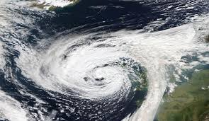

Typhoon Doksuri
Date: September 10th 2017 – September 16th 2017
Hazard: typhoon
Hazard details: 185km/h
Towns effected: south china, Vietnam and Thailand
Deaths: 36
Details:
Typhoon Doksuri was a strong typhoon that mostly impacted the philipeines and Vietnam forming as the nineteenth storm of the season.

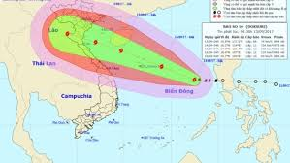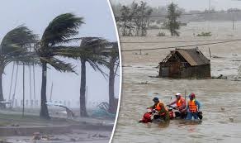

Iran Iraq earthquake
Date: November 12th 2017 – present
Hazard: earthquake
Hazard details: magnitude 7.3
Towns effected: Iran and Iraq
Deaths: 540+
Details:
An earthquake with a moment magnitude of 7.3 occurred along the Iran- Iraq border. Just inside Iran with an epicentre 30km south of Hadbja. With at least 540 deaths 530 in Iran and 10 in Iraq it is currently the deadliest earthquake of 2017.
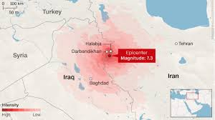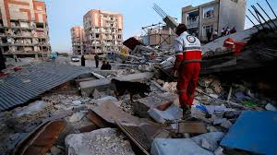

Flash floods Athens
Date: November 15th 2017- present
Hazard: flash flood
Hazard details: /
Towns effected: Athens, Mantra and Megra
Deaths: 15
Details:
Flash floods on the outskirts of Athens have killed at least 15 people injured dozens more and caused biblical damage.
Cars stuck in mud in hills where it is raining hard, homes have been flooded and people are missing, power lines down as the flood progresses.
